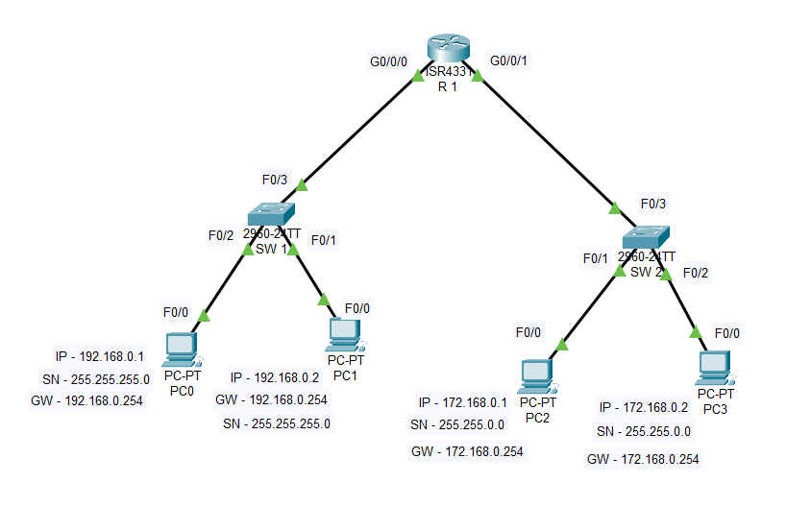
1. Configure Switches and Routers, assign hostnames and enable authentication to secure devices in the network.

Aim: To configure Switches and Routers, assign hostnames and enable authentication to secure devices in the network.
Algorithm:
Step 1: Start the process.
Step 2: Open Cisco packet tracer and place network devices and connect them as per requirement.
Step 3: Assign the IP address and gateway for each PC.
Step 4: In CLI of all switches enable secret password and line console password.
Step 5: In CLI of the router get into each interface and assign the IP address and enable them using no shutdown command.
Step 6: Verify the connections using ping.
Step 7: Stop the process.

Switch 1
#en
#config t
#hostname SW1
#enable secret kasc
#line console 0
#password kasc1
#login
#exit
#end
#interface f0/1-24
#no shutdown
#exit
#end
#wr
Switch 2
#en
#config t
#hostname SW2
#enable secret kasc
#line console 0
#password kasc1
#login
#exit
#end
#interface f0/1-24
#no shutdown
#exit
#end
#wr
Router 1
#en
#config t
#hostname R1
#enable secret kasc
#line console 0
#password kasc1
#login
#exit
#end
#interface g0/0/0
#ip addess 192.168.0.254 255.255.255.0
#no shutdown
#exit
#interface g0/0/1
#ip address 172.168.0.254 255.255.255.0
#no shutdown
#exit
#end
#wr
OUTPUT:

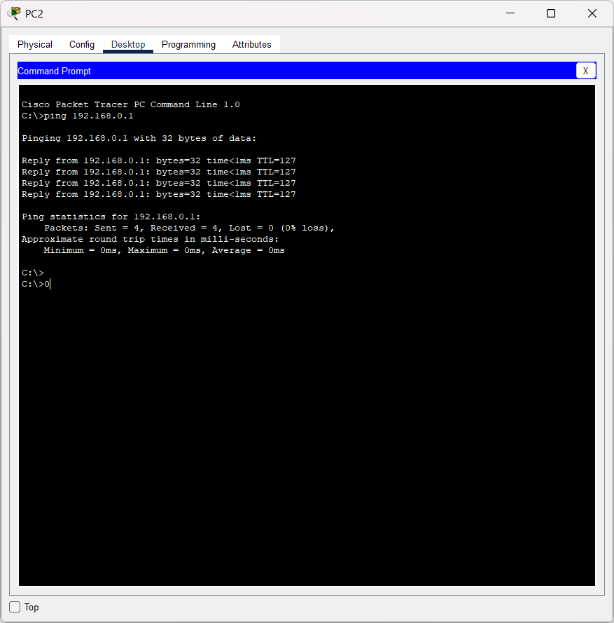

2. Setup VLAN interfaces on Switches and Routers, assign IP addresses and simulate LAN connectivity.

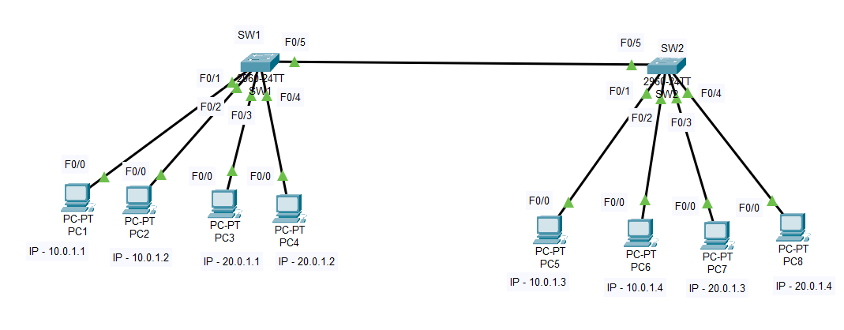
Aim: To setup VLAN interfaces on Switches and Routers, assign IP addresses and simulate LAN connectivity.
Algorithm:
Step 1: Start the process.
Step 2: Open Cisco packet tracer and place network devices and connect them as per requirement.
Step 3: Assign the IP address and gateway for each PC.
Step 4: In CLI of all the switches create VLANs and name them.
Step 5: In the interface that connects two switches, assign switchport mode trunk.
Step 6: In other interfaces, assign switchport access with respective vlan number.
Step 7: Verify the connections using ping.
Step 8: Stop the process.

Switch 1
>en
#config t
#vlan 10
#name VLAN10
#exit
#vlan 20
#name VLAN20
#exit
#config t
#interface f0/1
#switchport mode access
#switchport access vlan 10
#exit
#interface f0/2
#switchport mode access
#switchport access vlan 10
#exit
#interface f0/3
#switchport mode access
#switchport access vlan 20
#exit
#interface f0/4
#switchport mode access
#switchport access vlan 20
#exit
#config t
#interface f0/5
#switchport mode trunk
#exit
#end
#wr
Switch 2
>en
#config t
#vlan 10
#name VLAN10
#exit
#vlan 20
#name VLAN20
#exit
#end
#config t
#interface f0/1
#switchport mode access
#switchport access vlan 10
#exit
#interface f0/2
#switchport mode access
#switchport access vlan 10
#exit
#interface f0/3
#switchport mode access
#switchport access vlan 20
#exit
#interface f0/4
#switchport mode access
#switchport access vlan 20
#exit
#wr
#config t
#interface f0/5
#switchport mode trunk
OUTPUT
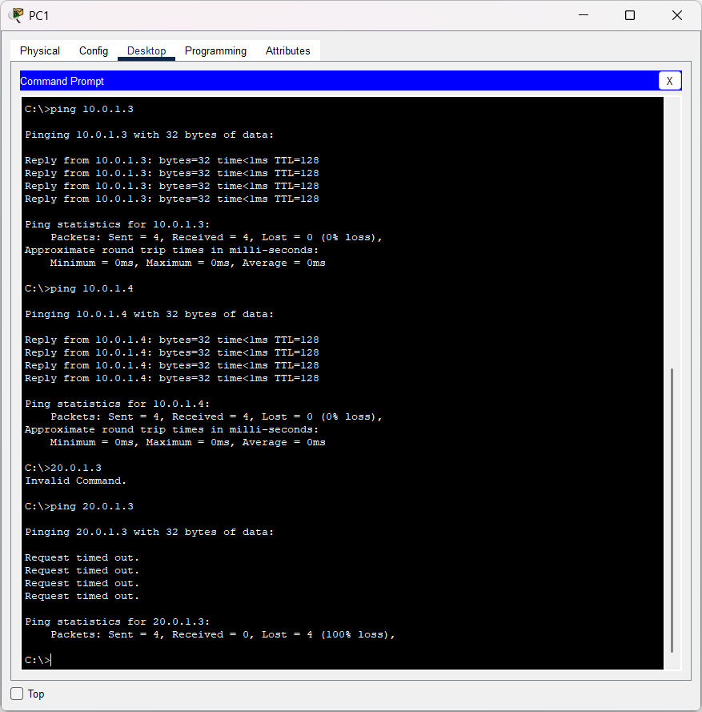

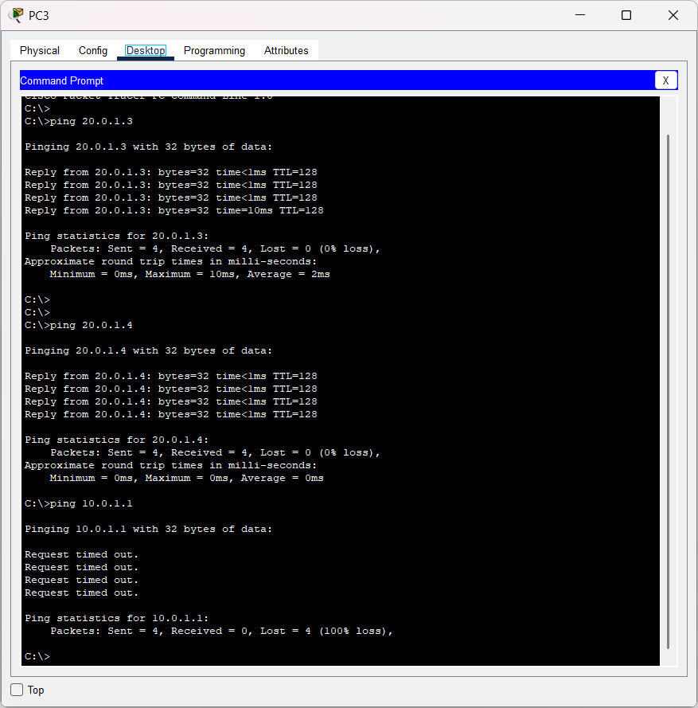

3. Configure and verify Static Routes between multiple routers.
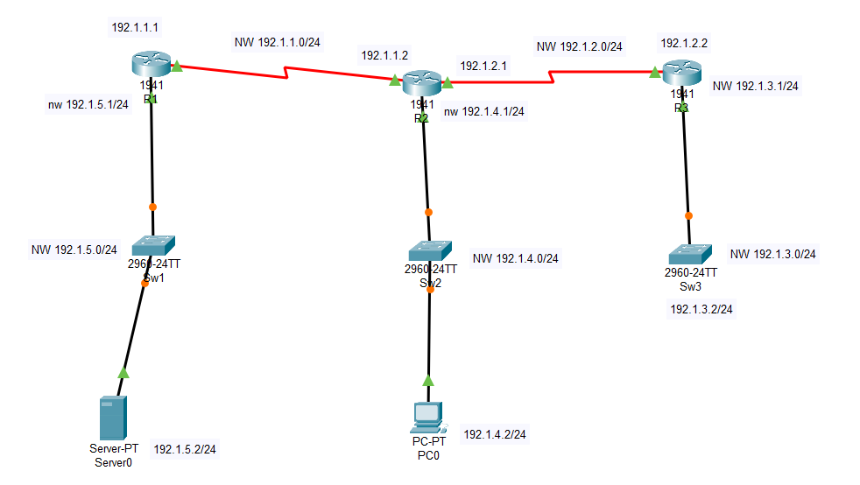
Aim: To configure and verify static routes between multiple routers.
Algorithm:
Step 1: Start the process.
Step 2: Open Cisco packet tracer and place network devices and connect them as per requirement, use serial port (NM2T) to connect between routers.
Step 3: Assign the IP address for the interfaces of routers.
Step 4: In configuration mode of routers, assign static route using the ip route command.
Step 5: In the interface vlan 1 of switches assign the ip address and assign the default gateway.
Step 6: Verify the connections using ping.
Step 7: Stop the process.

ROUTER 1
>enable
#configure terminal
#hostname R1

#interface gigabitEthernet 0/0
#ip address 192.1.5.1 255.255.255.0
#no shutdown
#exit
#interface serial 0/1/0
#ip address 192.1.1.1 255.255.255.0
#no shutdown
#exit
#ip route 0.0.0.0 0.0.0.0 serial 0/1/0 ← Default route to middle router
#end
R1#write

ROUTER 2
>enable
#configure terminal
#hostname R2

#interface gigabitEthernet 0/0
R2(config-if)#ip address 192.1.4.1 255.255.255.0
R2(config-if)#no shutdown
R2(config-if)#exit

#interface serial 0/1/0
R2(config-if)#ip address 192.1.1.2 255.255.255.0
R2(config-if)#no shutdown
R2(config-if)#exit

#interface serial 0/1/1
R2(config-if)#ip address 192.1.2.1 255.255.255.0
R2(config-if)#no shutdown
R2(config-if)#exit

#ip route 192.1.5.0 255.255.255.0 serial 0/1/0
#ip route 192.1.3.0 255.255.255.0 serial 0/1/1

#end
R2#write
----------------------------------------------------------------------------------\
ROUTER 3
>enable
#configure terminal
#hostname R3

R3(config)#interface gigabitEthernet 0/0
R3(config-if)#ip address 192.1.3.1 255.255.255.0
R3(config-if)#no shutdown
R3(config-if)#exit

R3(config)#interface serial 0/1/0
R3(config-if)#ip address 192.1.2.2 255.255.255.0
R3(config-if)#no shutdown
R3(config-if)#exit

R3(config)#ip route 0.0.0.0 0.0.0.0 serial 0/1/0

R3(config)#end
R3#write
SW 3:
>enable
#configure terminal
#hostname LAN3
LAN3(config)#interface vlan1
LAN3(config-if)#ip address 192.1.3.2 255.255.255.0
LAN3(config-if)#no shutdown
LAN3(config-if)#exit
LAN3(config)#ip default-gateway 192.1.3.1
LAN3(config)#end
LAN3#write
-----------------------------------------------------------
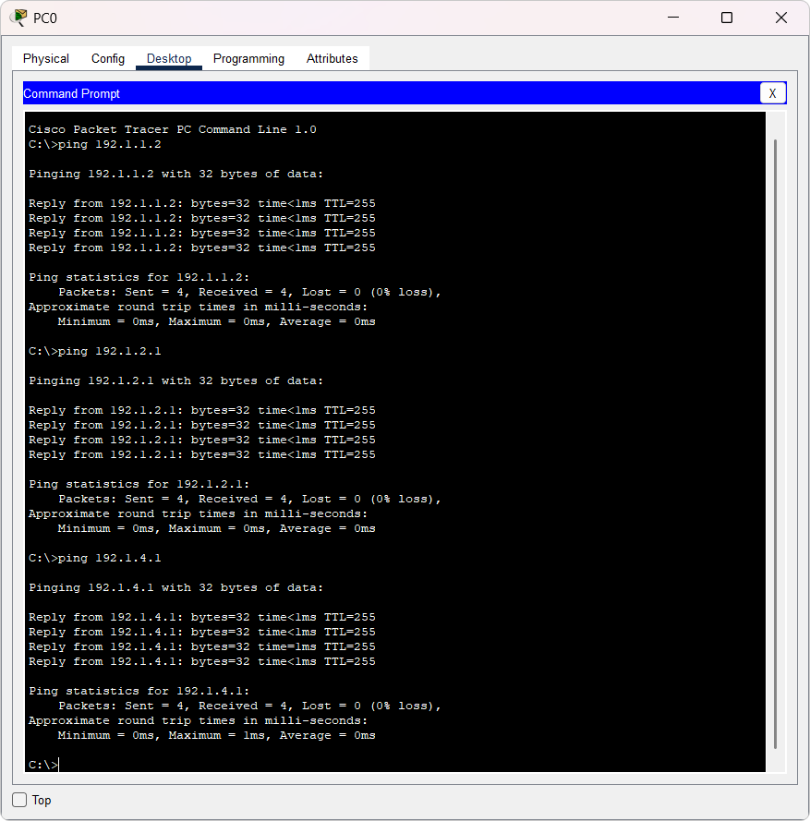

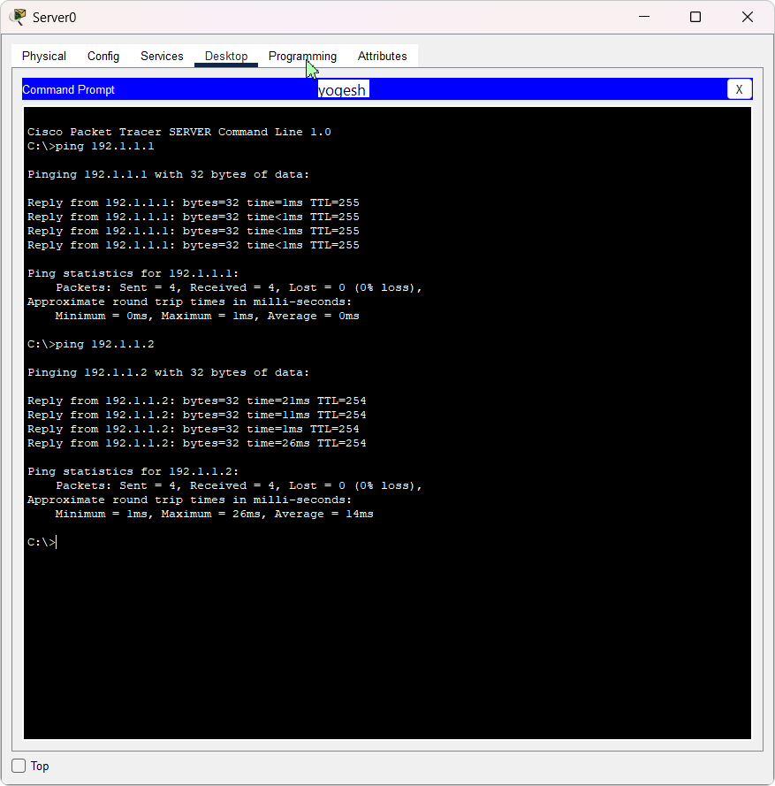

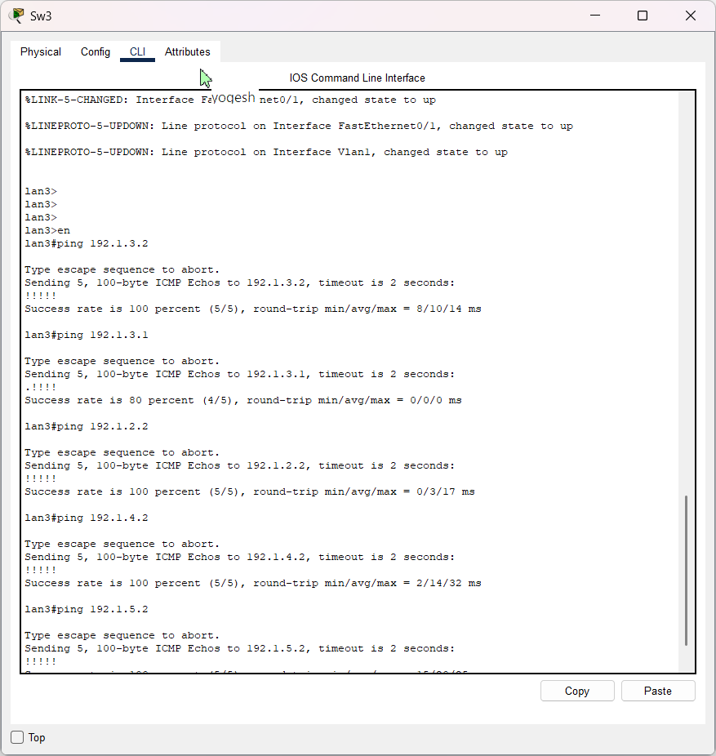

4. Implement and verify RIPv2 routing, show routing tables and IP route details.
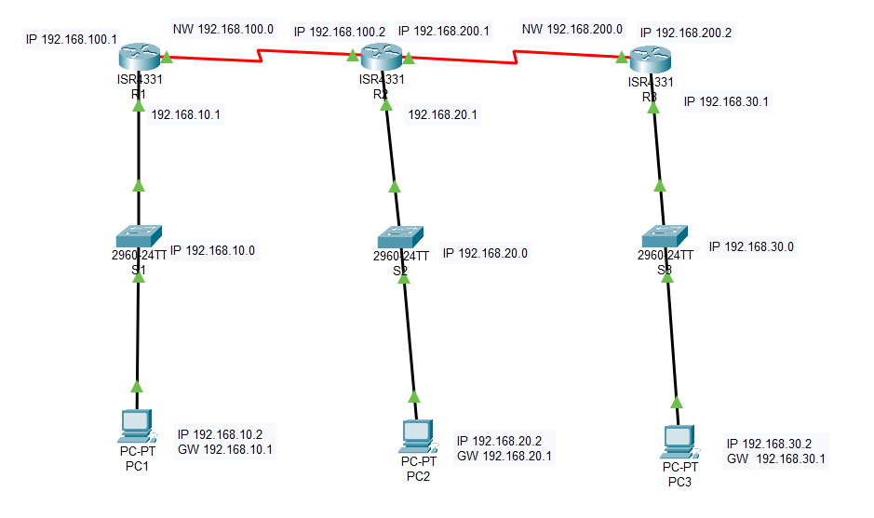
Aim: To implement and verify RIPv2 routing, show routing tables and IP route details.
Algorithm:
Step 1: Start the process.
Step 2: Open Cisco packet tracer and place network devices and connect them as per requirement, use serial port (NM2T) to connect between routers.
Step 3: Assign the IP address for all PC and assign IP address for the interfaces of routers.
Step 4: In configuration mode of routers, configure RIP V2 and discover their networks.
Step 5: Verify the connections using ping, tracert and show ip route, ip protocols and ip rip database.
Step 6: Stop the process.
Router1:
>enable
#configure terminal
#hostname R1
#interface g0/0/0
#ip address 192.168.10.1 255.255.255.0
#no shutdown

#interface s0/1/0
#ip address 192.168.100.1 255.255.255.0
#no shutdown

#router rip
R1(config-router)#version 2
R1(config-router)#no auto-summary
R1(config-router)#network 192.168.10.0
R1(config-router)#network 192.168.100.0
R1(config-router)#exit
#end
R1#write
-----------------------------------------------------------
Router 2
>enable
#configure terminal
#hostname R2
#interface g0/0/0
R2(config-if)#ip address 192.168.20.1 255.255.255.0
R2(config-if)#no shutdown

#interface s0/1/0
R2(config-if)#ip address 192.168.100.2 255.255.255.0
R2(config-if)#no shutdown

#interface s0/1/1
R2(config-if)#ip address 192.168.200.1 255.255.255.0
R2(config-if)#no shutdown

#router rip
R2(config-router)#version 2
R2(config-router)#no auto-summary
R2(config-router)#network 192.168.20.0
R2(config-router)#network 192.168.100.0
R2(config-router)#network 192.168.200.0
R2(config-router)#exit
#end
R2#write
Router 3
>enable
#configure terminal
#hostname R3
R3(config)#interface g0/0/0
R3(config-if)#ip address 192.168.30.1 255.255.255.0
R3(config-if)#no shutdown

R3(config)#interface s0/1/0
R3(config-if)#ip address 192.168.200.2 255.255.255.0
R3(config-if)#no shutdown

R3(config)#router rip
R3(config-router)#version 2
R3(config-router)#no auto-summary
R3(config-router)#network 192.168.30.0
R3(config-router)#network 192.168.200.0
R3(config-router)#exit
R3(config)#end
R3#write
-----------------------------------------------------------
OUTPUT :
Run command from PC 192.168.10.2
Ping 192.168.30.2
tracert 192.168.30.2
Run command from PC 192.168.30.2
Ping 192.168.10.2
tracert 192.168.10.2
Run following commands in all Routers
1. show ip protocols
2. show ip route
3. show ip rip database
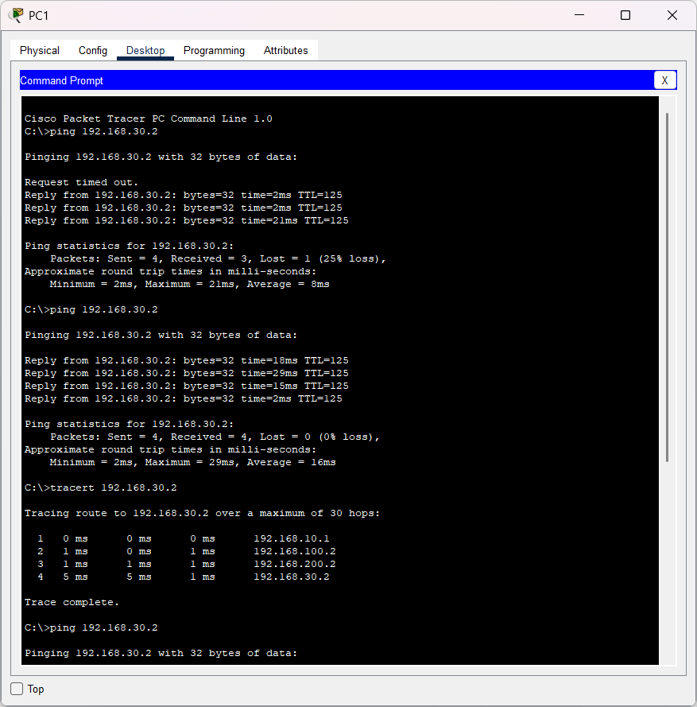
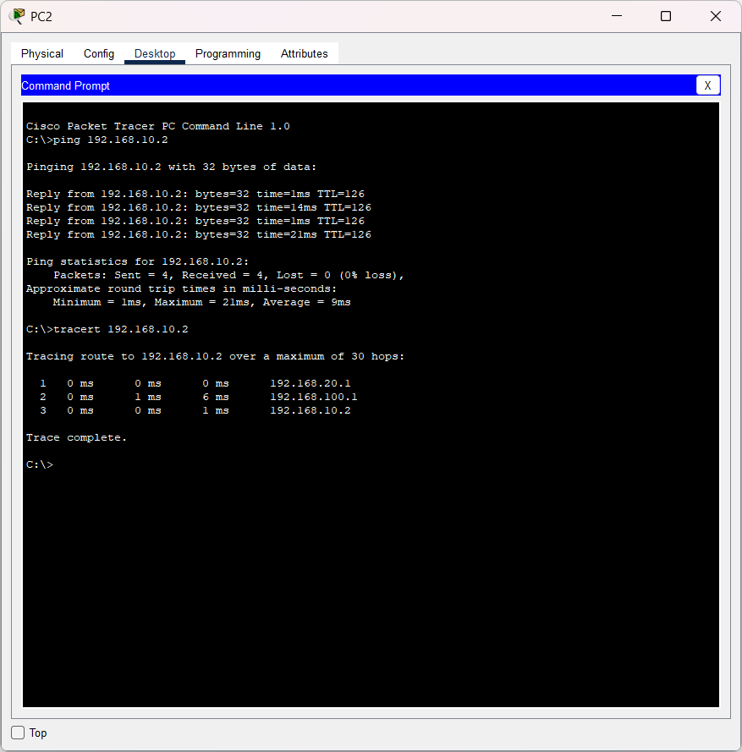

5. Configure EIGRP and show EIGRP neighbors and analyze EIGRP topology.

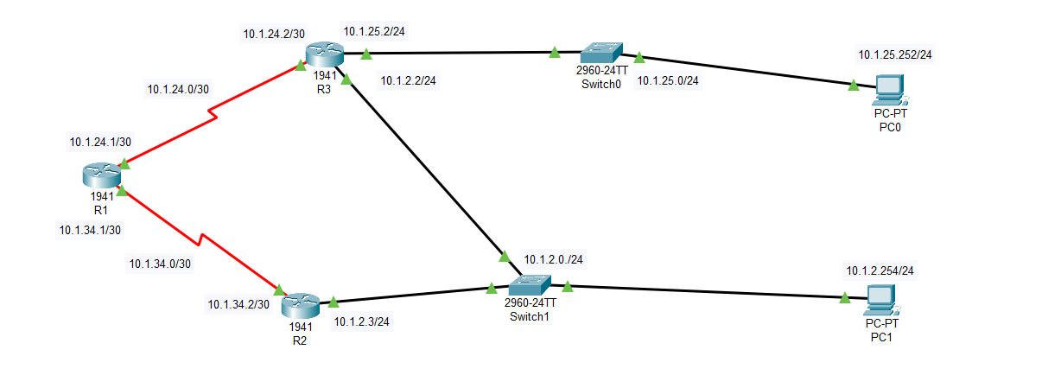
Aim: To configure EIGRP and show EIGRP neighbors and analyze EIGRP topology.
Algorithm:
Step 1: Start the process.
Step 2: Open Cisco packet tracer and place network devices and connect them as per requirement, use serial port (NM2T) to connect between routers.
Step 3: Assign the IP address for all PC and assign IP address for the interfaces of routers.
Step 4: In configuration mode of routers, configure EIGRP using the command router eigrp 50 and discover their networks.
Step 5: Verify the connections using ping, and show ip route, ip eigrp neighbors, ip route eigrp and ip eigrp topology.
Step 6: Stop the process.

ROUTER 1
>enable
#configure terminal
#hostname R1

#interface s0/1/0
#ip address 10.1.24.1 255.255.255.252
#no shutdown
#exit

#interface s0/1/1
#ip address 10.1.34.1 255.255.255.252
#no shutdown
#exit

#router eigrp 50
#no auto-summary
#network 10.1.24.0 0.0.0.3
#network 10.1.34.0 0.0.0.3
#end
#wr

ROUTER 2
>enable
#configure terminal
#hostname R2

#interface s0/1/0
#ip address 10.1.34.2 255.255.255.252
#no shutdown
#exit

#interface g0/0/0
#ip address 10.1.2.3 255.255.255.0
#no shutdown
#exit

#router eigrp 50
#no auto-summary
#network 10.1.34.0 0.0.0.3
#network 10.1.2.0 0.0.0.255
#end
#wr

ROUTER 3
#configure terminal
#hostname R3
#interface s0/1/0
#ip address 10.1.24.2 255.255.255.252
#no shutdown
#exit
#interface g0/0/0
#ip address 10.1.2.2 255.255.255.0
#no shutdown
#exit
#interface g0/0/1
#ip address 10.1.25.2 255.255.255.0
#no shutdown
#exit
#router eigrp 50
#no auto-summary
#network 10.1.24.0 0.0.0.3
#network 10.1.25.0 0.0.0.255
#network 10.1.2.0 0.0.0.255
#end
#wr

pc0
IP Address: 10.1.25.254
Subnet Mask: 255.255.255.0
Default Gateway: 10.1.25.2
pc1
IP Address: 10.1.2.254
Subnet Mask: 255.255.255.0
Default Gateway: 10.1.2.3

Check following commands in all routers
R3#show ip route
R3#show ip eigrp neighbors
R3#show ip route eigrp
R3#show ip eigrp topology

OUTPUT
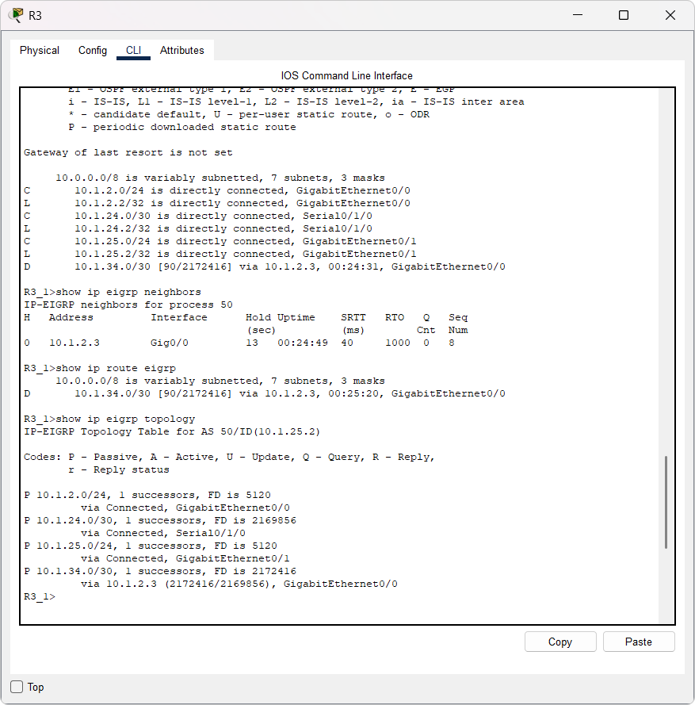

6. Build an OSPF based network using three interconnected routers.
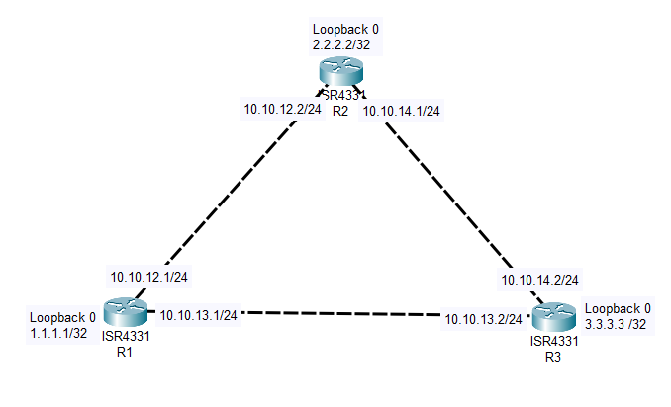
Aim: To build an OSPF based network using three interconnected routers.
Algorithm:
Step 1: Start the process.
Step 2: Open Cisco packet tracer and place three network devices and connect them.
Step 3: Assign the loopback address for the interface loopback 0 and IP address for the interfaces of routers as required.
Step 4: In configuration mode of routers, configure ospf using the command ip ospf 1 area 1.
Step 5: Verify the connections using ping.
Step 6: Stop the process.
Router 1
>enable
#configure terminal
#hostname R1

#interface loopback 0
#ip address 1.1.1.1 255.255.255.255
#ip ospf 1 area 1
#no shutdown
#exit

#interface g0/0/0
#ip address 10.10.12.1 255.255.255.0
#ip ospf 1 area 1
#no shutdown
#exit

#interface g0/0/1
#ip address 10.10.13.1 255.255.255.0
#ip ospf 1 area 1
#no shutdown
#exit

Router 2

>enable
#configure terminal
#hostname R2_CSA66
R2_CSA66(config)#interface loopback 0
R2_CSA66(config-if)#ip address 2.2.2.2 255.255.255.255
R2_CSA66(config-if)#ip ospf 1 area 1
R2_CSA66(config-if)#no shutdown
R2_CSA66(config-if)#exit

R2_CSA66(config)#interface g0/0/0
R2_CSA66(config-if)#ip address 10.10.12.2 255.255.255.0
R2_CSA66(config-if)#ip ospf 1 area 1
R2_CSA66(config-if)#no shutdown
R2_CSA66(config-if)#exit

R2_CSA66(config)#interface g0/0/1
R2_CSA66(config-if)#ip address 10.10.14.1 255.255.255.0
R2_CSA66(config-if)#ip ospf 1 area 1
R2_CSA66(config-if)#no shutdown
R2_CSA66(config-if)#exit

Router 3

>enable
#configure terminal
#hostname R3_CSA66

R3_CSA66(config)#interface loopback 0
R3_CSA66(config-if)#ip address 3.3.3.3 255.255.255.255
R3_CSA66(config-if)#ip ospf 1 area 1
R3_CSA66(config-if)#no shutdown
R3_CSA66(config-if)#exit

R3_CSA66(config)#interface g0/0/0
R3_CSA66(config-if)#ip address 10.10.13.2 255.255.255.0
R3_CSA66(config-if)#ip ospf 1 area 1
R3_CSA66(config-if)#no shutdown
R3_CSA66(config-if)#exit

R3_CSA66(config)#interface g0/0/1
R3_CSA66(config-if)#ip address 10.10.14.2 255.255.255.0
R3_CSA66(config-if)#ip ospf 1 area 1
R3_CSA66(config-if)#no shutdown
R3_CSA66(config-if)#exit

Final Test: Ping from Loopback to Loopback

From R1:
ping 2.2.2.2
ping 3.3.3.3
--------------------
From R2
ping 1.1.1.1
ping 3.3.3.3
---------------------
From R3:
ping 1.1.1.1
ping 2.2.2.2

All routers:
sh ip int br
show ip ospf neighbor
show ip route
show ip protocols
show ip ospf
show ip ospf interface
OUTPUT

